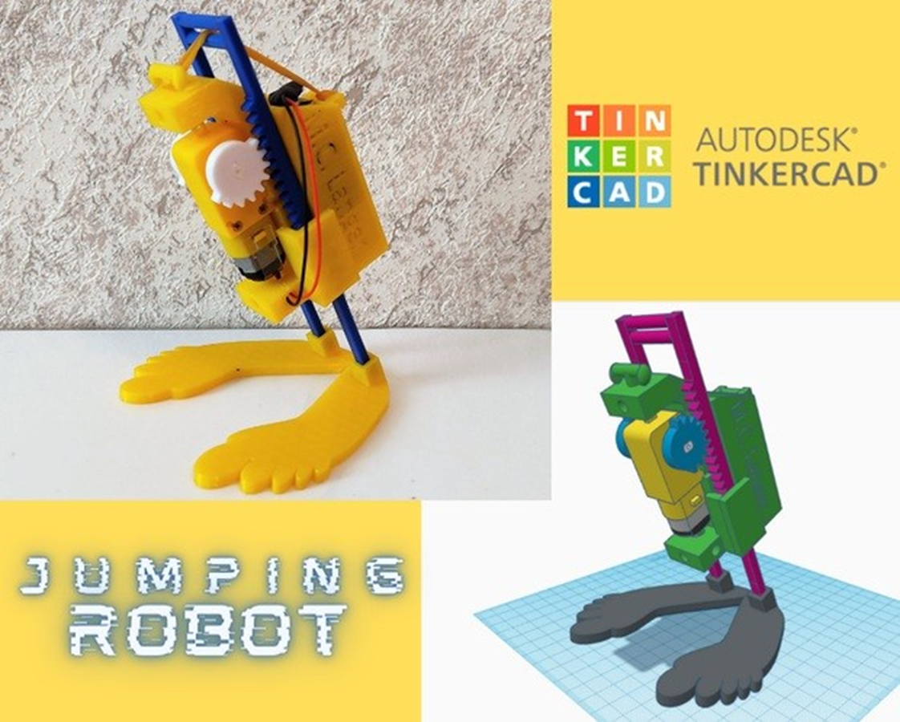**Supplies:**

1 rubber band

Zip-ties

1 Clip Connector for 9V battery

1 9V battery.

**OPTIONAL:**

* 1 SPDT slide switch,
* soldering iron,
* soldering tin.

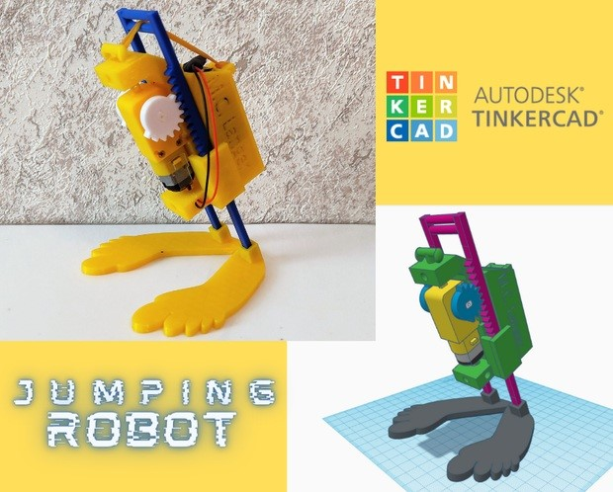

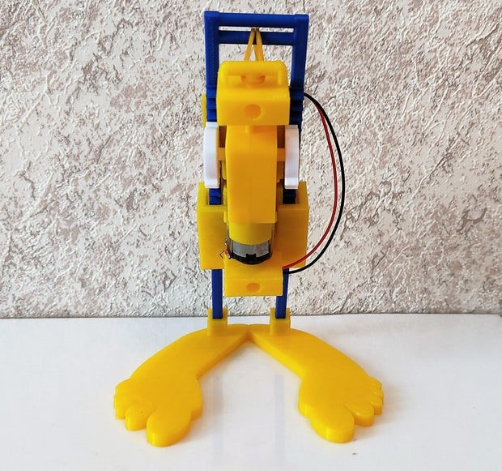

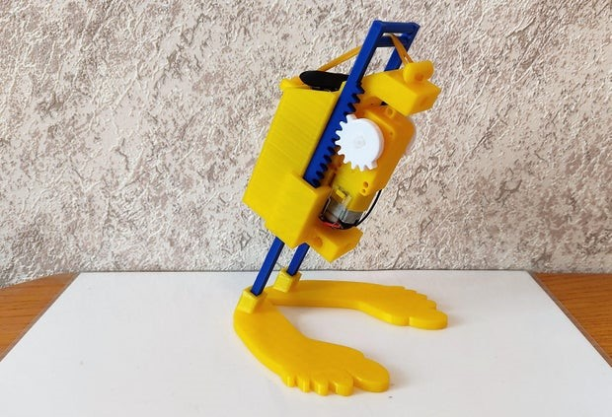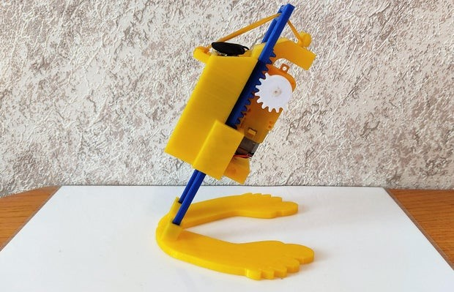

# Step 1: Attaching the Gears

Attach the gears on each end of the shaft. Check that both gears have the teeth aligned, so they can hit and release the stilts at the same time. Attach the gears using glue gun.

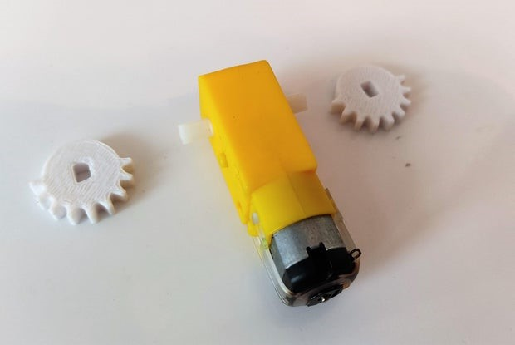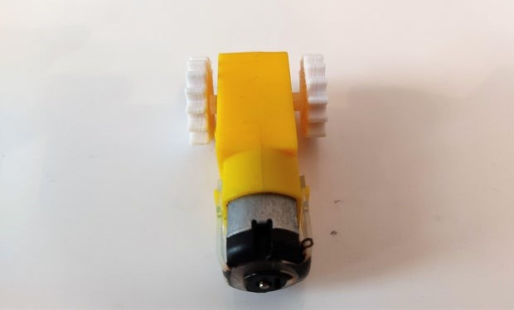

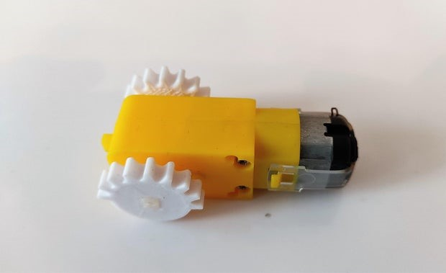

# Step 2: Attach the gearbox to the 3D printed body, using an zip-tie. Tighten it, then cut the remaining part.

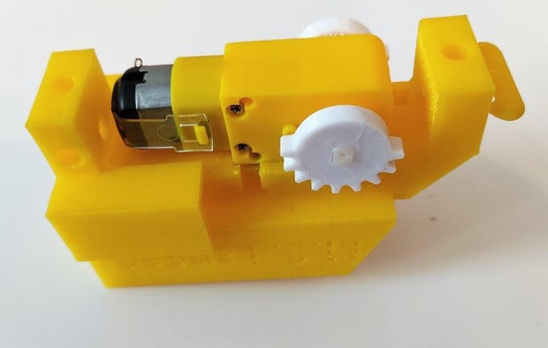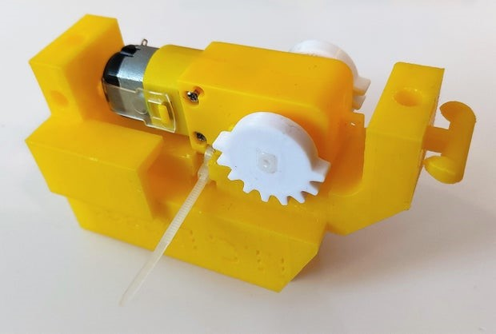

# Step 3: Inserting the Stilts

Insert the stilts from top to bottom of the body. The groove must be on top.

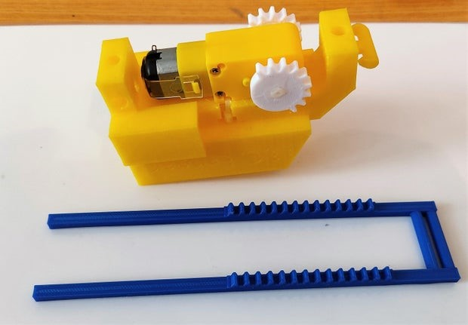

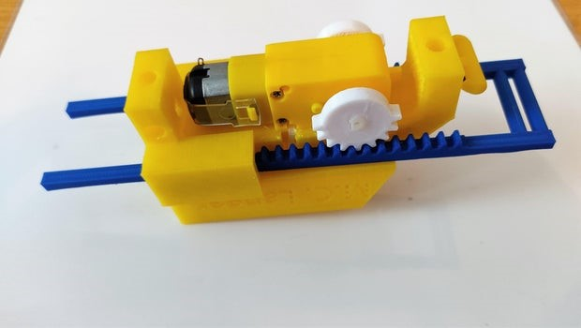

# Step 4: Adding the Feet

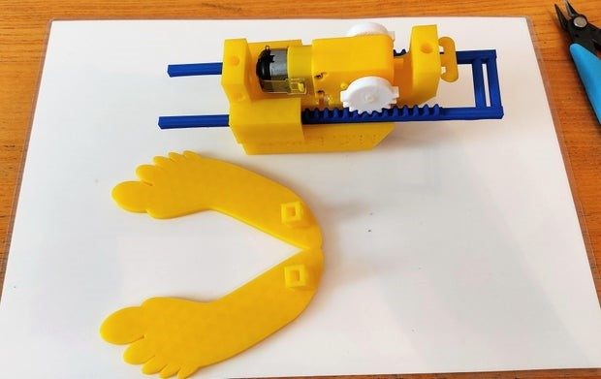Attach the feet to the lowest part of the stilts. Use superglue if needed

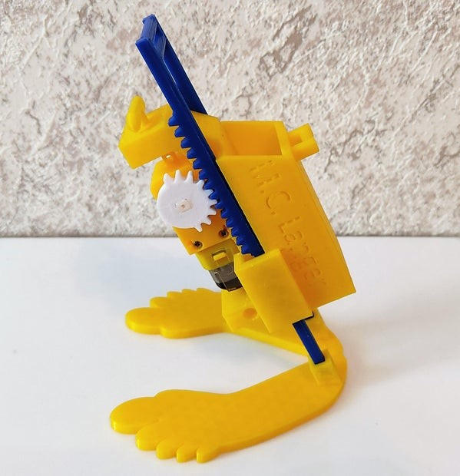

# Step 5: Electrical Circuit

Place the battery into the backpack, and connect the wires to the pins of the motor. In this position, the red wire must be in front, and the black wire must be closer to the body.

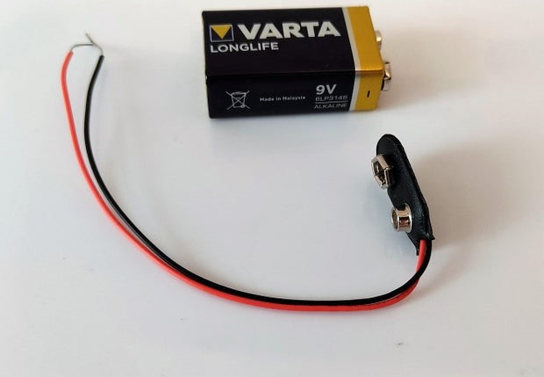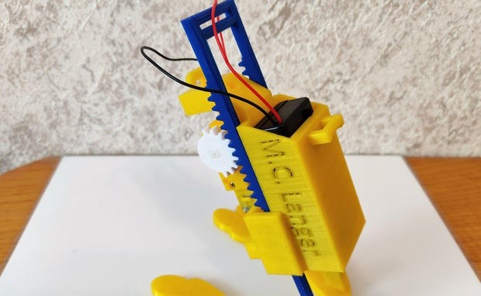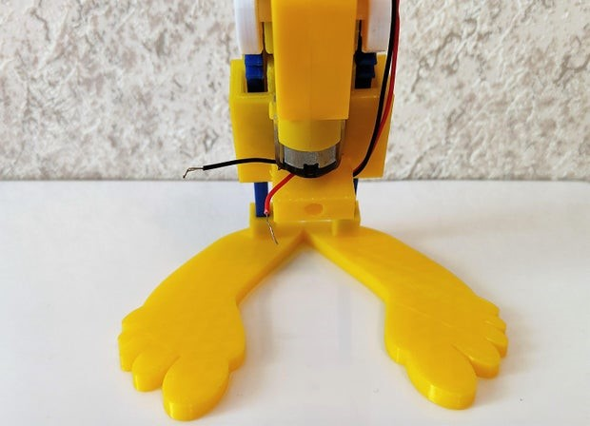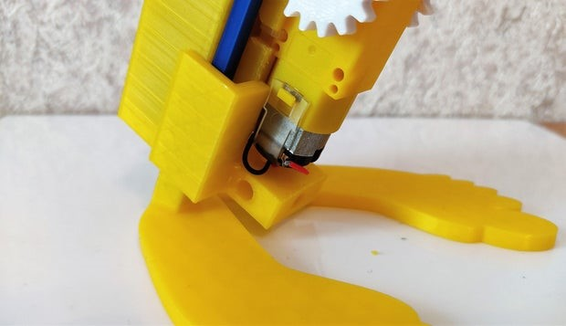

# Step 6: The Rubber Band

Tie the rubber band to the back's lug, using a Lark's head (cow hitch) knot. Pass the rubber band through the top groove on the stilts, then secure it on the hooks placed on front of the body.

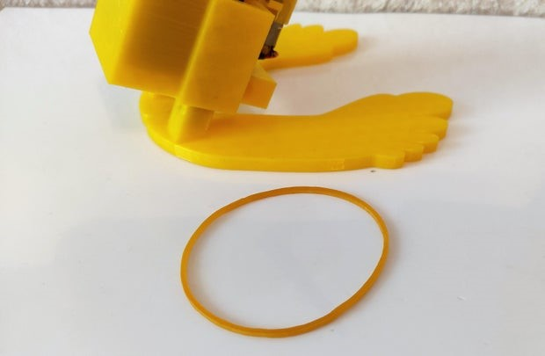

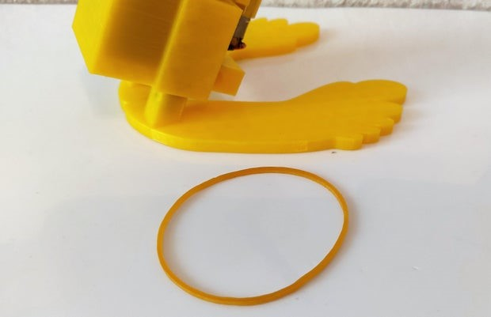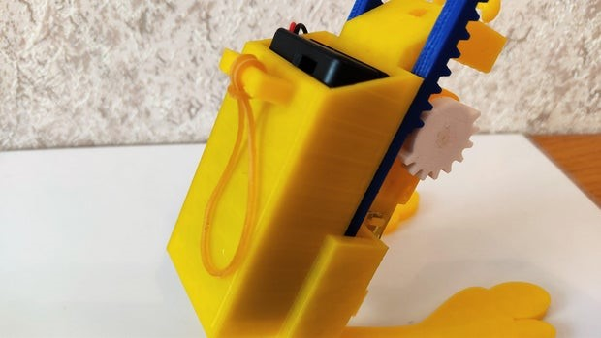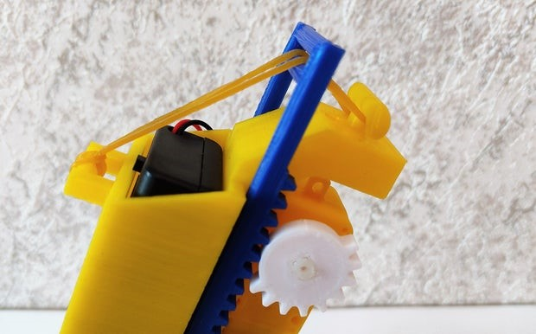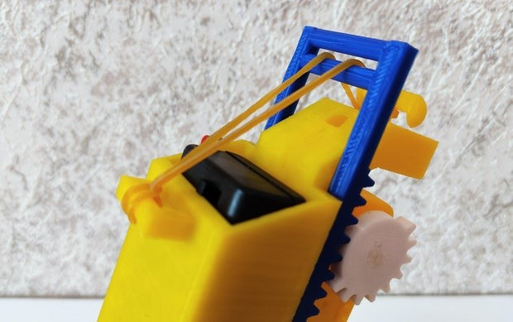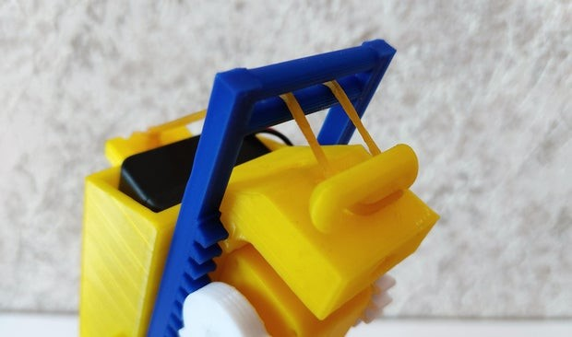

**Step 18: Ready to Go!**

Your Jumping Robot is ready. You just need to connect both pins of the brackets to the battery. As optional step, you can also add a switch, so it's easier to turn your robot on and o . The Body's STL has a space where you can place it. Time to take over the world, one jump at the time. :-) 